**Introduction to Statistical Methods**

**(S2-22_AIMLCZC418– Assignment 2)**

**AIML- Section-3**

1. A confidence interval of 4cms for average heights of students with 99% confidence is required. The standard deviation is 8cms. What should be the sample size?

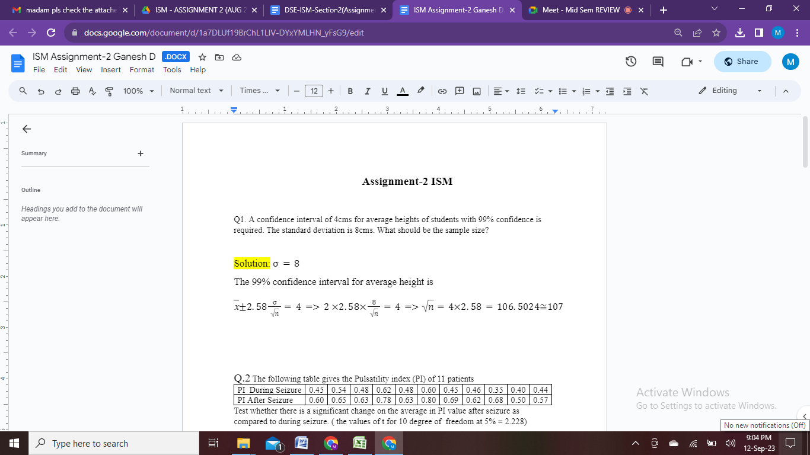

1. The following table gives the Pulsality index (PI) of 11 patients

|  |  |  |  |  |  |  |  |  |  |  |  |
| --- | --- | --- | --- | --- | --- | --- | --- | --- | --- | --- | --- |
| PI During Seizure | 0.45 | 0.54 | 0.48 | 0.62 | 0.48 | 0.60 | 0.45 | 0.46 | 0.35 | 0.40 | 0.44 |
| PI After Seizure | 0.60 | 0.65 | 0.63 | 0.78 | 0.63 | 0.80 | 0.69 | 0.62 | 0.68 | 0.50 | 0.57 |

Test whether there is a significant change on the average in PI value after seizure as compared to during seizure. (The values of t for 10 degreesof freedom at 5% = 2.228).

Solution:

H0: No significant change

H1: Significant Change

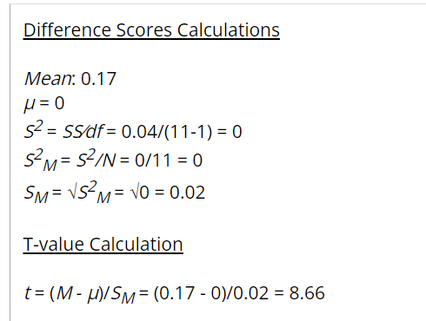

Ho is rejected

1. A certain drug was administered to 450 persons out of a total of 800 persons in a certain locality to test its efficiency against typhoid. The results are given below in the table. Find out the effectiveness of the drug against the disease.

|  |  |  |  |
| --- | --- | --- | --- |
|  | Infection | No Infection | Total |
| Drug | 200 | 300 | 500 |
| No drug | 250 | 50 | 300 |
| Total | 450 | 350 | 800 |

Solution:

Ho: The drug is not effective in controlling typhoid

H1: The drug is effective in controlling typhoid

|  |  |
| --- | --- |
| O | E |
| 200 | 281.25 |
| 300 | 218.75 |
| 250 | 168.75 |
| 50 | 131.25 |

Χ2=143.07>3.84(0.05) Ho is rejected.

4. From the data given below, find out whether the means of the three samples differ significantly or not

|  |  |  |
| --- | --- | --- |
| Sample-1 | Sample-2 | Sample-3 |
| 20 | 19 | 13 |
| 10 | 13 | 12 |
| 17 | 17 | 10 |
| 17 | 12 | 15 |
| 16 | 9 | 5 |

Solution:

H0: No significant change

H1: Significant Change

|  |  |  |  |  |
| --- | --- | --- | --- | --- |
| Source of variation | DF | SS | MS | F |
| Between samples | c-1=2 | 63.33 | 31.67 |  |
| Within | C(r-1)=12 | 176 | 14.67 | 31.67  F = ----------- = 2.16  14.67 |
| Total | 14 | 239.33 |  |  |
| **F-cal < F-table ie., 2.16 < 3.9  Ho is accepted** | | | | |